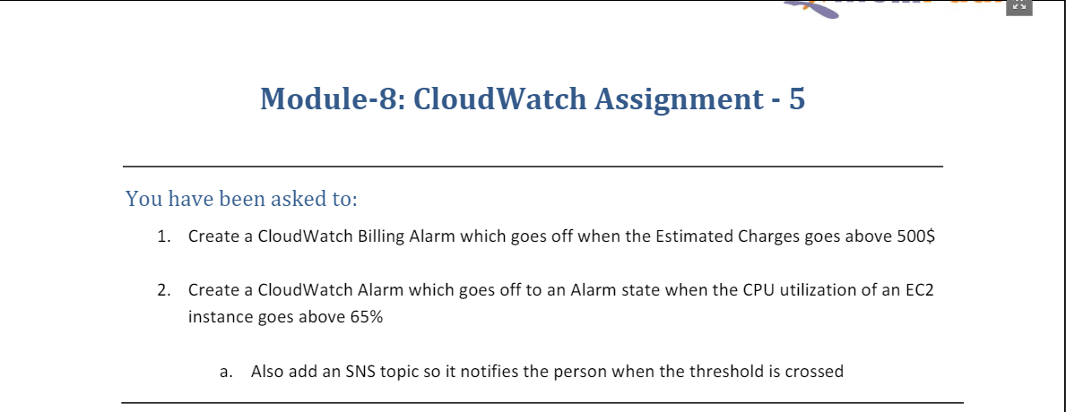

1. For this we head to CloudWatch section and then to Billing under Alarms and then click on Create Alarm

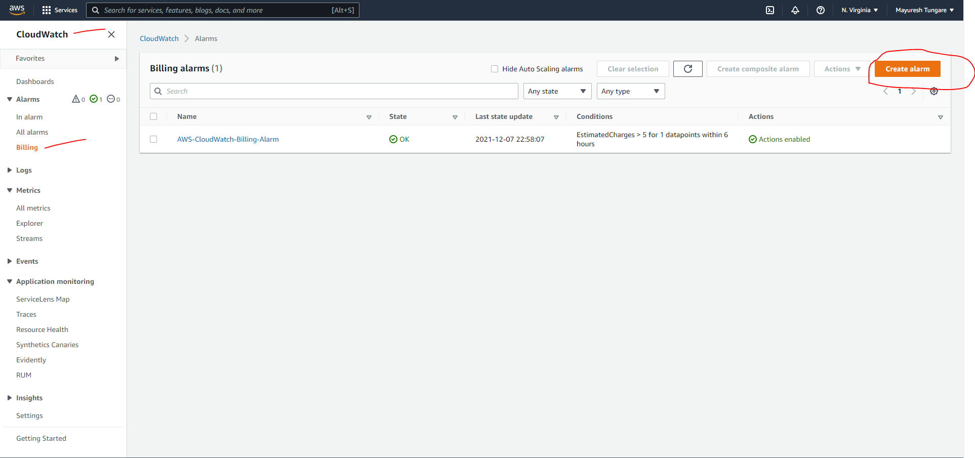

1. We then select metric and total estimated charge and then set the threshold for alarm to be set off when total charge exceeds 500 USD (as shown below):

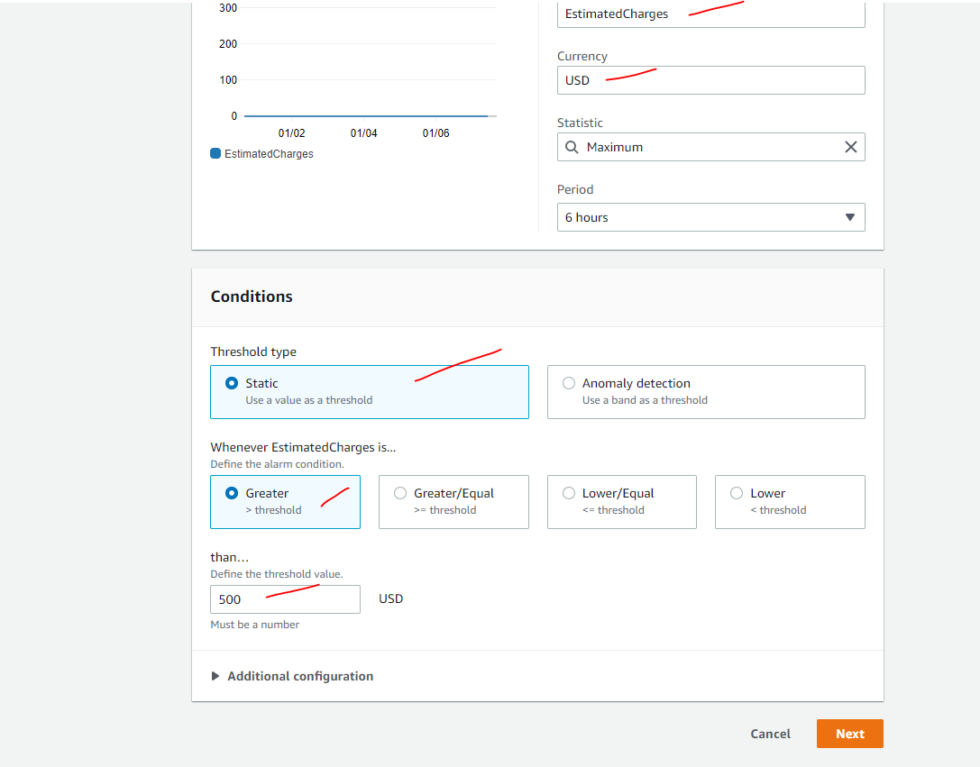

1. Next, we create a SNS topic and add a valid email id for it to receive the notification when alarm goes off.

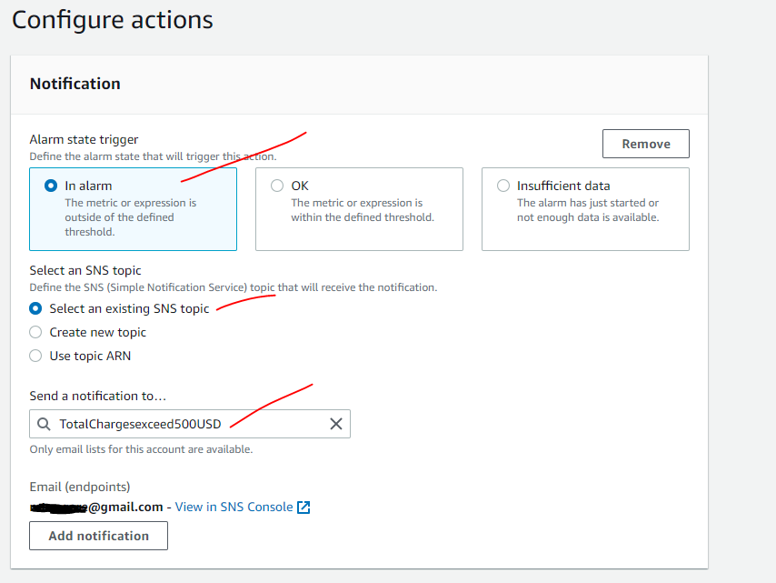

1. Once all the information is entered and we click on create alarm, we see a confirmation as below:

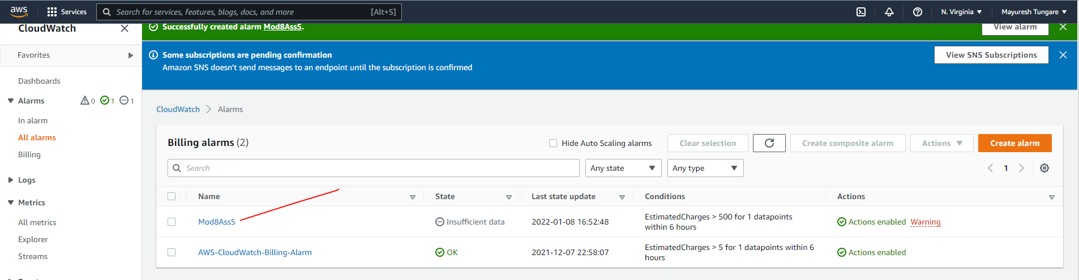

1. Thus, first part of the assignment is complete.
2. For the second the part of this assignment, we create a alarm as shown in earlier steps for CPU utilization of EC2 instance and set threshold at 65%.

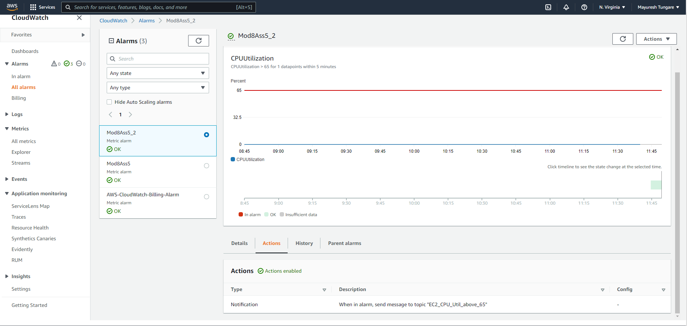

1. Thus, this assignment is now complete.